**ROBOTICS AND AUTOMATION**

**(ECE 2008)**

**J-Component**

Reverse Parking Sensor

WINTER SEMESTER 2017_2018

SLOT- G1

*Submitted By*

ADHEIK DOMINIC-16BEC0620

*Under the guidance of*

Prof. Vinod Kumar E

Associate Professor, SENSE

VIT University-Vellore



**CERTIFICATE**

This is to certify that the project work entitled “**Reverse Parking Sensor**” submitted by

ADHEIK DOMINIC-16BEC0620

to Vellore Institute of technology, Vellore, is a project bonafide work carried out by them under my supervision.

Prof. .Vinod Kumar E

Supervisor

Associate Professor

SENSE

**ACKNOWLEDGEMENT**

We would like to express our special thanks and gratitude to our professor and the project guide Prof. Vinod Kumar E . as well as VIT University who gave us this golden opportunity to work on this wonderful project on the topic Microprocessor and Interfacing, which also helped us in doing a lot of research and we came to know about so many new things, we are really thankful to them.

We would also like to thank all the participants of our survey to co-operate with us and gave their precious time.

Place: Vellore

Date: 25/03/2018

**TABLE OF CONTENTS**

|  |  |  |
| --- | --- | --- |
| **Serial No.** | **Title** | **Page No.** |
| 1 | ABSTRACT | 5 |
| 2 | INTRODUCTION | 6 |
| 3 | PROPOSED MODEL | 7 |
| 4 | MATERIALS REQUIRED | 8 |
| 5 | ARDUINO CODE IMPLEMENTATION | 9 |
| 6 | PROJECT MODEL | 11 |
| 7 | FUTURE ENHANCEMENTS | 12 |
| 8 | REFERENCES | 14 |

**ABSTRACT**

# Why this project?

# If you are a new driver then it is very difficult to judge the distance while parking the car. Reverse parking sensor circuit solves this problem by indicating the distance with the help of three LED’s. We can easily arrange this system at the back side of the car. This system operates with 12V rechargeable battery. Th explains you how to design Reverse parking sensor. We can also use the same concept in IR Water Level Detector Circuit also.The distance between car and obstacle is understood by the group of LED’s (D5 to D7). If the distance between car and obstacle is 25cm then D7 will glow. At the distance of 20cm D7 and D6 LEDs turn ON and at a distance of 5cm all LED’s (D5, D6, D7) glow. When the distance is more than 25cm then all LED’s will turn off.

**INTRODUCTION**

Parking sensor circuit mainly consists of two sections, one is transmitter section and the other is receiver section. The transmitter section uses [**NE555 timer IC as an a stable multivibrator**](https://www.electronicshub.org/understanding-555-timer/) for driving the IR transmitter. The transmitter frequency is set to be 120Hz.The IR pulses transmitted by the IR transmitter are reflected back because of the obstacle and received by the IR receiver. The received signal is amplified by the U2:A. The output voltage of the Peak detector (R4 and c4) is proportional to the distance between car bumper and obstacle. The output voltage of the peak detector is given to the inputs of three comparators U2: B, U2: C and U2:D . These comparators switch the status LED’s according to the input voltage and the reference voltage. This circuit can be used in auto mobiles to park the vehicle safely. We can use this circuit to measure the distance. We can also use this circuit as IR Liquid Level Detector by making few modifications.IR receiver may receive the normal light. As a result, parking sensor may not work properly. We should arrange IR sensors accurately; otherwise they may not detect the obstacle.

**PROPOSED MODEL**

This project consists of a pair of ultrasonic sensors connected to an Arduino in which a blind person can wear as glasses, in order to calculate distances between the blind user and any immediate obstacles (walls, doors, chairs, etc.) that are left or right of them. The distances are then translated into a series of audio beeps with the delays between them getting smaller when the user is nearing an obstacle (the user can wear bone conduction headphones). Two independent left/right audio channels are used in order to give the blind user a sense of orientation in an unknown environment through his/her left and right ears.

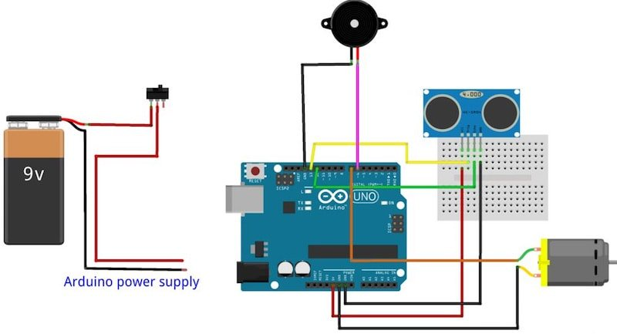

**MATERIALS REQUIRED**

1. Arduino Uno Microcontroller- The Arduino Uno is a microcontroller board based on the ATmega328. It has 14 digital input/output pins (of which 6 can be used as PWM outputs), 6 analog inputs, a 16 MHz ceramic resonator, a USB connection, a power jack, an ICSP header, and a reset button. Arduino is open source hardware board with many open source libraries to interface it on board microcontroller with many other external components like LED, motors, LCD, keypad, Bluetooth module, GSM module and many other things one wants to interface with Arduino board. Arduino is basically make from a microcontroller but Arduino have all external socket to connect with other devices and it also have built in programmer which is used to program Arduino from computer. So, Arduino is a complete board which include all things to connect with external peripheral and to program through computer.
2. HC- SR04 Ultrasonic Sensor- Ultrasonic sensor is a distance measurement sensor which uses ultrasonic sound waves to measure distance. Ultrasonic sensor uses high frequency sound waves of 40 KHz. Ultrasonic sensor consists of two basic modules transmitter and receiver. Transmitter acts as speaker and receiver acts as a microphone. Speaker emits ultrasonic waves and Microphone detects ultrasonic waves which is produced by speaker. Basic functionality of ultrasonic sensor is shown in diagram.

The distance to the object can be found out by formula given below.

D = 0.5 * C * (T1-T0)

where

- D = Distance to Object.

- C= Speed of sound

- T0 = Time at which sonic wave is transmitted

- T1 = Time at which sonic wave is received

1. 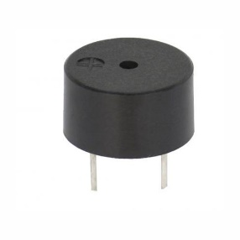Buzzer- A **buzzer** or **beeper** is an audio signalling device, which may be mechanical, electromechanical, or piezoelectric (*piezo* for short). Typical uses of buzzers and beepers include alarm devices, timers and confirmation of user input such as a mouse click or keystroke.

**ARDUINO CODE IMPLEMENTATION**

con

st int pingPin = 7;

const int led = 12;

const int buzzer = 9;

void setup() {

// initialize serial communication:

Serial.begin(9600);

pinMode(led, OUTPUT);

pinMode(buzzer, OUTPUT);

}

void loop() {

// establish variables for duration of the ping,

// and the distance result in inches and centimeters:

long duration, inches, cm;

// The PING))) is triggered by a HIGH pulse of 2 or more microseconds.

// Give a short LOW pulse beforehand to ensure a clean HIGH pulse:

pinMode(pingPin, OUTPUT);

digitalWrite(pingPin, LOW);

delayMicroseconds(2);

digitalWrite(pingPin, HIGH);

delayMicroseconds(5);

digitalWrite(pingPin, LOW);

// The same pin is used to read the signal from the PING))): a HIGH

// pulse whose duration is the time (in microseconds) from the sending

// of the ping to the reception of its echo off of an object.

pinMode(pingPin, INPUT);

duration = pulseIn(pingPin, HIGH);

// convert the time into a distance

inches = microsecondsToInches(duration);

cm = microsecondsToCentimeters(duration);

if (inches >= 48 && inches < 72) {

digitalWrite(buzzer, HIGH);

digitalWrite(led, HIGH);

delay(100);

digitalWrite(buzzer, LOW);

digitalWrite(led, LOW);

delay(700);

} else if (inches < 48) {

digitalWrite(buzzer, HIGH);

digitalWrite(led, HIGH);

delay(100);

digitalWrite(buzzer, LOW);

digitalWrite(led, LOW);

delay(50);

} else if (inches > 72) {

digitalWrite(buzzer, LOW);

// digitalWrite(led, HIGH);

}

digitalWrite(led, HIGH);

Serial.print(inches);

Serial.print("in, ");

Serial.print(cm);

Serial.print("cm");

Serial.println();

delay(100);

}

long microsecondsToInches(long microseconds) {

// According to Parallax's datasheet for the PING))), there are

// 73.746 microseconds per inch (i.e. sound travels at 1130 feet per

// second). This gives the distance travelled by the ping, outbound

// and return, so we divide by 2 to get the distance of the obstacle.

return microseconds / 74 / 2;

}

long microsecondsToCentimeters(long microseconds) {

// The speed of sound is 340 m/s or 29 microseconds per centimeter.

// The ping travels out and back, so to find the distance of the

// object we take half of the distance travelled.

return microseconds / 29 / 2;

}

**PROJECT MODEL**

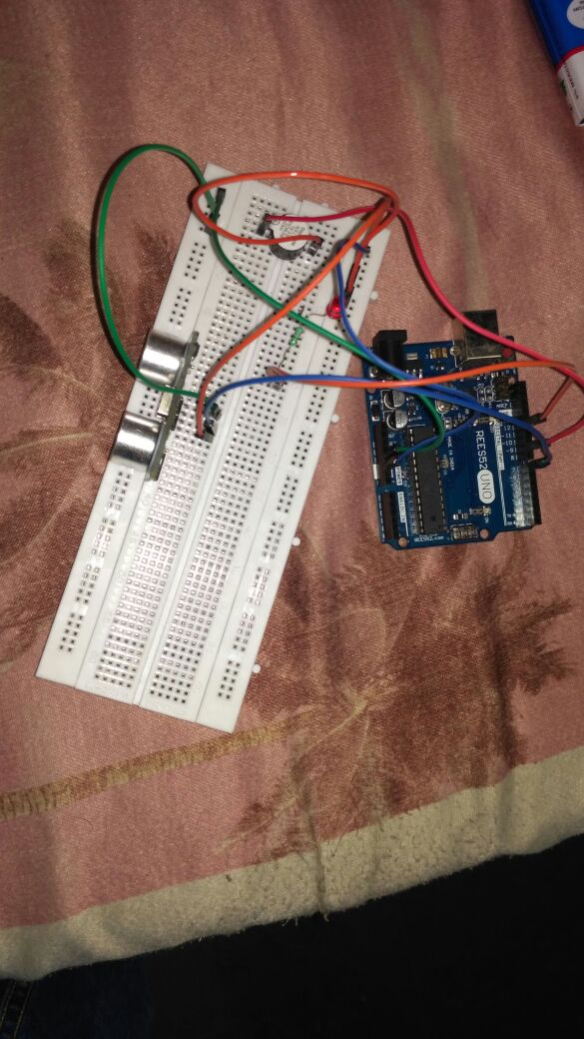

**FUTURE ENHANCEMENTS**

The model proposed in this project is a very simple but effective prototype. More enhancements can be done in the near future to increase the efficiency of the Smart Glasses

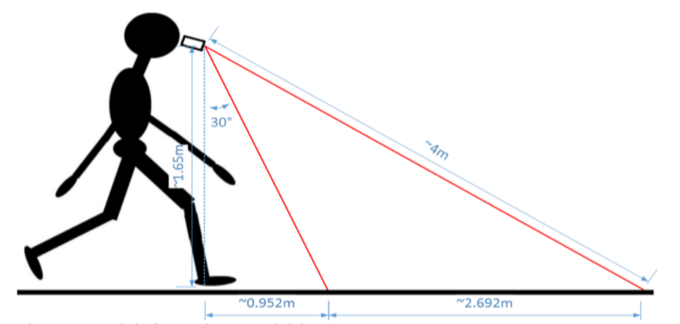The main drawback of the current prototype is that the blind man cannot judge whether there is flat surface or stairs. To avoid this Depth sensor can be added to the model. Depth information is acquired with the depth sensor which can be found in RGB-D camera module. The depth sensor is composed by an infrared laser source that project non-visible light with a coded pattern combined with a monochromatic CMOS (Complementary Metal Oxide Semiconductor) image sensor that captures the reflected light. The algorithm that deciphers the reflected light coding generates the depth information representing the scene. In this project, the depth information can be acquired by mounting the depth sensor onto the glasses with an approximate inclination of 30°, as shown in Figure on the right. This way, considering the height of the camera to the ground to be about 1.65 m and the depth camera working range to be limited about from 0.4 m to 4 m, the valid distance in field of view is about 2.692 m, starting about 0.952 m in front of the user.

Another drawback is that Ultrasonic sensor-based method can measure the distance of obstacle and compare it with the given distance threshold for deciding whether to go ahead, but it cannot determine the exact direction of going forward and may suffer from interference problems with the sensors themselves if ultrasonic radar (ultrasonic sensor array) is used, or other signals in indoor environment. Although laser scanner-based method is widely used in mobile robot navigation for their high precision and resolution, the laser scanner is expensive, heavy, and with high power consumption, so it is not suitable for wearable navigation system. As for camera-based method, there are many methods based on different cameras, such as mono-camera, stereo-camera, and RGB-D camera. Based on the mono-camera, some methods process RGB image to detect obstacles by e.g., floor segmentation, deformable grid-based obstacle detection etc. However, these methods cost so much computation that they are not satisfied for real-time applications, and hard to measure the distance of the obstacle. To measure the distance, some stereo-camera based methods are proposed. For example, the method uses local window based matching algorithms for estimating the distance of obstacles, and the method uses genetic algorithm to generate dense disparity maps that can also estimate the distance of obstacles. However, these methods will fail under low-texture or low-light scenarios, which cannot ensure the secure navigation.

Here in this prototype buzzer has been used to identify the obstacle in front of the person. Although they have far less interference with sensing the environment, they are hard to represent complicated information and require more training and concentration. Audio feedback-based systems utilize acoustic patterns, semantic speech, different intensities sound or spatially localized auditory cues. Using acoustic patterns directly maps the processed RGB image to acoustic patterns for helping the blind to perceive the surroundings. The semantic speech method maps the depth image to semantic speech for telling the blind some information about the obstacles. Visual feedback-based systems can be used for the partially sighted individuals due to its ability of providing more detailed information than haptic or audio feedback-based systems. Visual feedbacks map the distance of the obstacle to brightness on LED (Light Emitting Diode) display as a visual enhancement method to help the users more easily to notice the obstacle. But, the LED display only shows the large obstacle due to its low resolution.   
So, to overcome all these difficulties a novel multi-sensor fusion based obstacle avoiding algorithm can 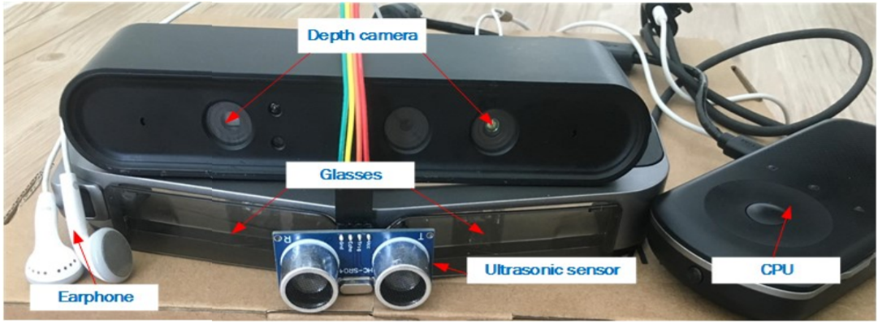proposed which utilizes both the depth sensor and ultrasonic sensor to find the optimal traversable direction. The output traversable direction can then be converted to three kinds of auditory cues in order to select an optimal one under different scenarios and integrated in the AR technique based visual enhancement for guiding the visually impaired people.

**REFERENCES**

1. Sensor Based Assistance System for Visually Impaired - Vigneshwari, Vimala, Sumithra International Journal of Engineering Trends and Technology (IJETT) – Volume 4 Issue 10 - Oct 2013
2. Smart Guiding Glasses for Visually Impaired People in Indoor Environment Jinqiang Bai, Shiguo Lian, Member, IEEE, Zhaoxiang Liu, Kai Wang, Dijun Liu
3. SonicScape Binaural Glasses   
   <https://hackaday.io/project/20899-sonicscape-binaural-sensor-glasses-for-the-blind>
4. Smart vision for the blind people - R. Mohanapriya, U. Nirmala, C. Pearlin Priscilla  
   ISSN: 2278 – 909X International Journal of Advanced Research in Electronics and Communication Engineering (IJARECE) Volume 5, Issue 7, July 2016